**EXEC() SYSTEM CALL**

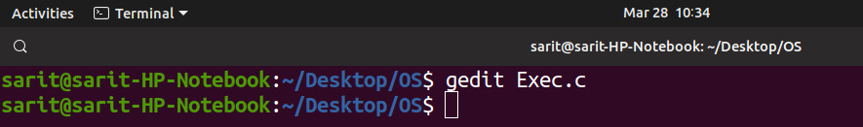

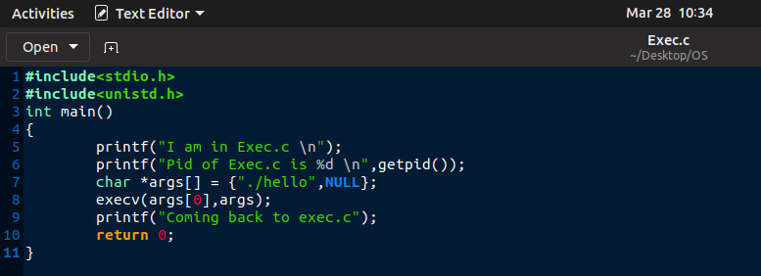

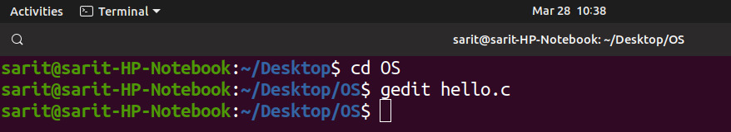

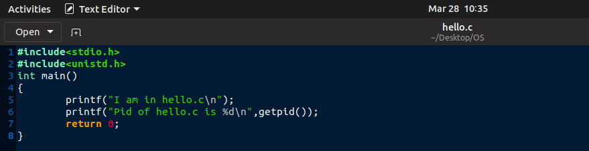

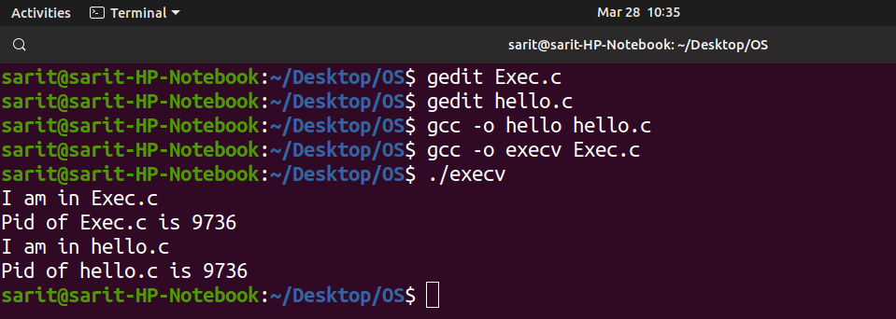

**OPEN() SYSTEM CALL**

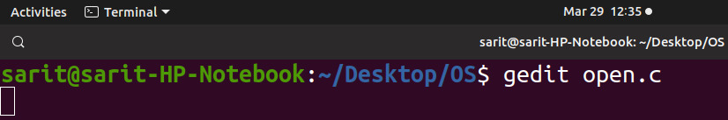

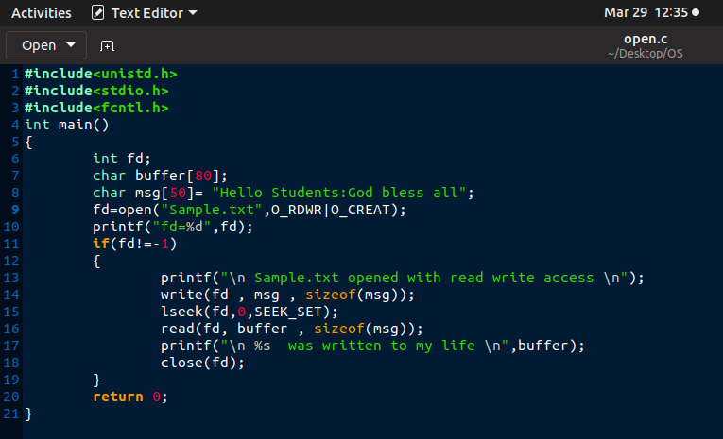

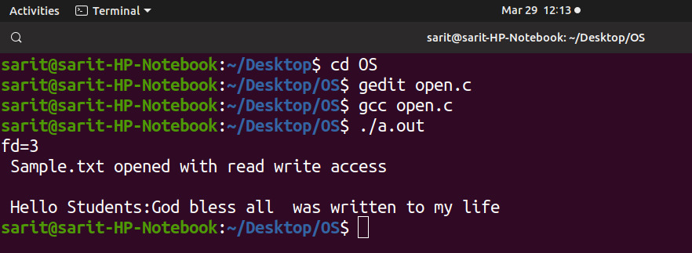



-------------X--------------

SUBMITTED BY- PIYUSH CHANDRA CHANDRA

ID – 1811100001027, SEMESTER – 4TH

SISTER NIVEDITA UNIVERSITY